

**University Institute of Engineering**

**Lab File**

**Subject Name: COMPUTER PROGRAMMING AND UTILIZATION LAB**

**Subject Code: UCP-145**

**Batch: 2017 -2021**

**Submitted By: Submitted To:**

**Name: Chirag Rawal Ms Prathiba Vasu**

**UID: 17BCS4132**

**Computer Science and Engineering IBM, Chandigarh University, Gharuan**

|  |  |  |  |  |  |  |  |  |  |
| --- | --- | --- | --- | --- | --- | --- | --- | --- | --- |
| **CPU LAB INDEX** | | | | | | | | | |
| **Student Name: Chirag Rawal** | | | | | **UID: 17BCS4132** | | | | |
| **Subject Name: Computer Programming and Utilization** | | | | | **Subject Code:** | | | | |
| **Branch & Section: CSE IBM CC2** | | | | | **Group: 1** | | | | |
| **S. No.** | **Name of Experiment** | **Page No.** | **Date** | **Marks** | | | | | **Teacher’s Signature** |
| **LW** | | **FW** | **VW** | **TM** |
| **12** | | **10** | **8** | **30** |
|  |  |  |  |  | |  |  |  |  |
|  |  |  |  |  | |  |  |  |  |
|  |  |  |  |  | |  |  |  |  |
|  |  |  |  |  | |  |  |  |  |
|  |  |  |  |  | |  |  |  |  |
|  |  |  |  |  | |  |  |  |  |
|  |  |  |  |  | |  |  |  |  |
|  |  |  |  |  | |  |  |  |  |
|  |  |  |  |  | |  |  |  |  |
|  |  |  |  |  | |  |  |  |  |
|  |  |  |  |  | |  |  |  |  |
|  |  |  |  |  | |  |  |  |  |
|  |  |  |  |  | |  |  |  |  |
|  |  |  |  |  | |  |  |  |  |
|  |  |  |  |  | |  |  |  |  |
|  |  |  |  |  | |  |  |  |  |
| **S. No.** | **Name of Experiment** | **Page No.** | **Date** | **Marks** | | | | | **Teacher’s Signature** |
| **LW** | | **FW** | **VW** | **TM** |
| **12** | | **10** | **8** | **30** |
|  |  |  |  |  | |  |  |  |  |
|  |  |  |  |  | |  |  |  |  |
|  |  |  |  |  | |  |  |  |  |
|  |  |  |  |  | |  |  |  |  |
|  |  |  |  |  | |  |  |  |  |
|  |  |  |  |  | |  |  |  |  |
|  |  |  |  |  | |  |  |  |  |
|  |  |  |  |  | |  |  |  |  |
|  |  |  |  |  | |  |  |  |  |
|  |  |  |  |  | |  |  |  |  |
|  |  |  |  |  | |  |  |  |  |
|  |  |  |  |  | |  |  |  |  |
|  |  |  |  |  | |  |  |  |  |
|  |  |  |  |  | |  |  |  |  |
|  |  |  |  |  | |  |  |  |  |
|  |  |  |  |  | |  |  |  |  |
|  |  |  |  |  | |  |  |  |  |
|  |  |  |  |  | |  |  |  |  |
|  |  |  |  |  | |  |  |  |  |
|  |  |  |  |  | |  |  |  |  |
|  |  |  |  |  | |  |  |  |  |
|  |  |  |  |  | |  |  |  |  |
|  |  |  |  |  | |  |  |  |  |

**EXPERIMENT 1:**

**Aim:** Write a program which finds the roots of a quadratic equation. Get values of multipliers a, b and c from user input.

**Program:**

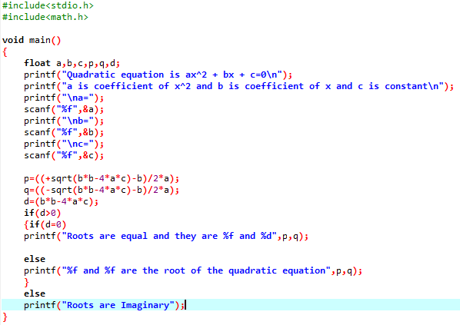

**Input and Output:**

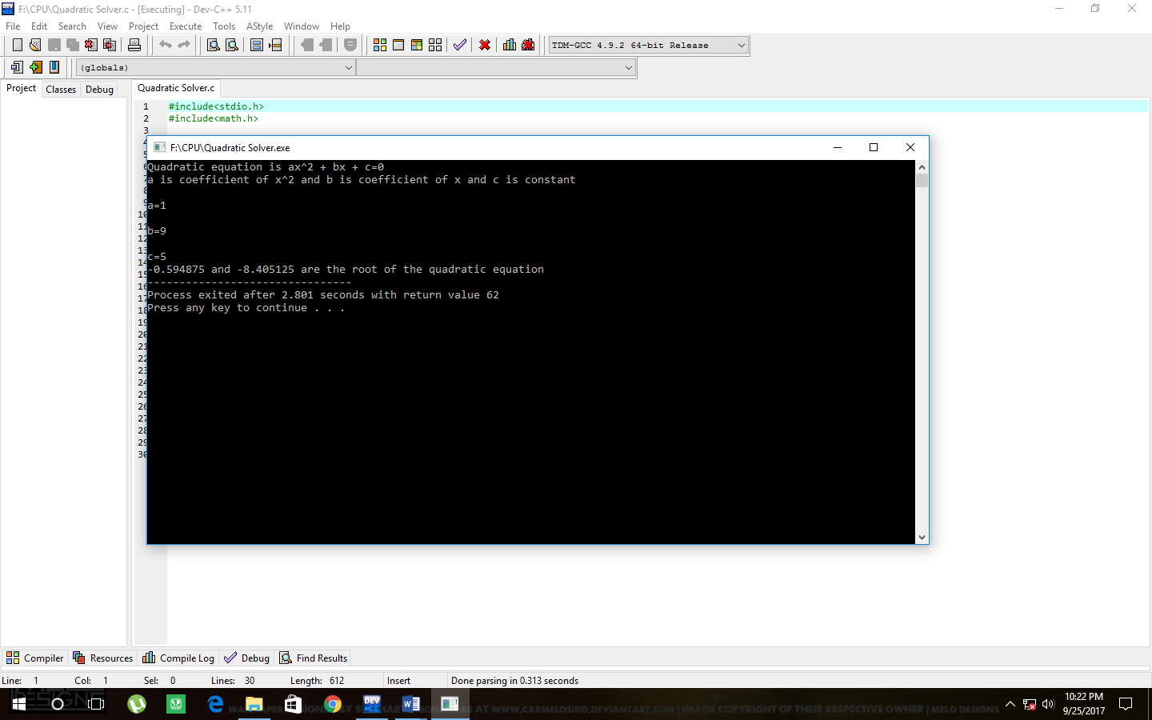

**Aim:** Write a program to find cos, sin and tan of a given angle.

**Program:**

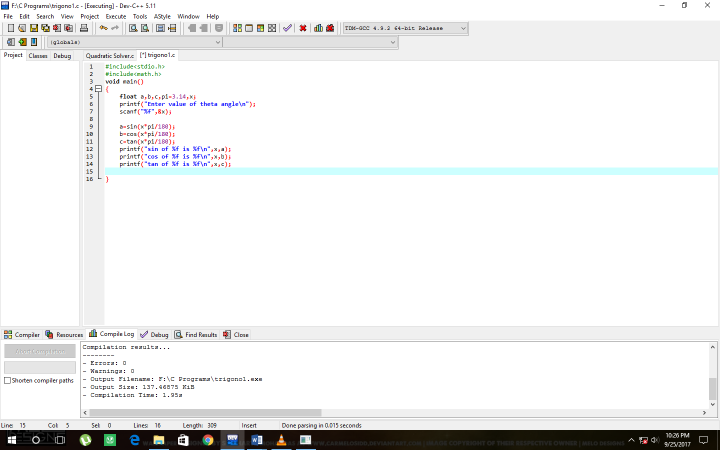

**Input and Output:**

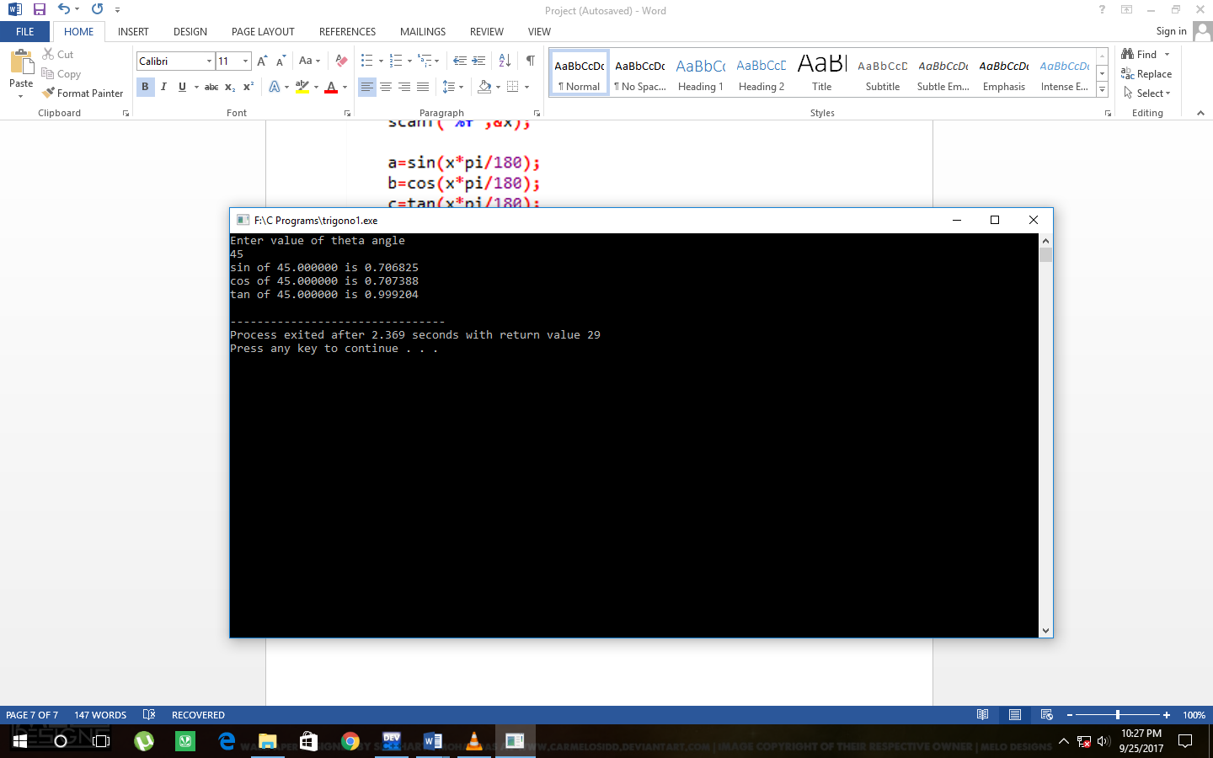

**EXPERIMENT 2:**

**Aim:** Write a program to get an integer number (4 digit) as an input and display all digits of that number separate on each line with its individual weightage. For example, if input is 8921, the display should be:

Last digit = 1 having weightage = 1

Next digit = 2 having weightage = 20

Next digit = 9 having weightage = 900

Next digit = 8 having weightage = 8000

**Program:**

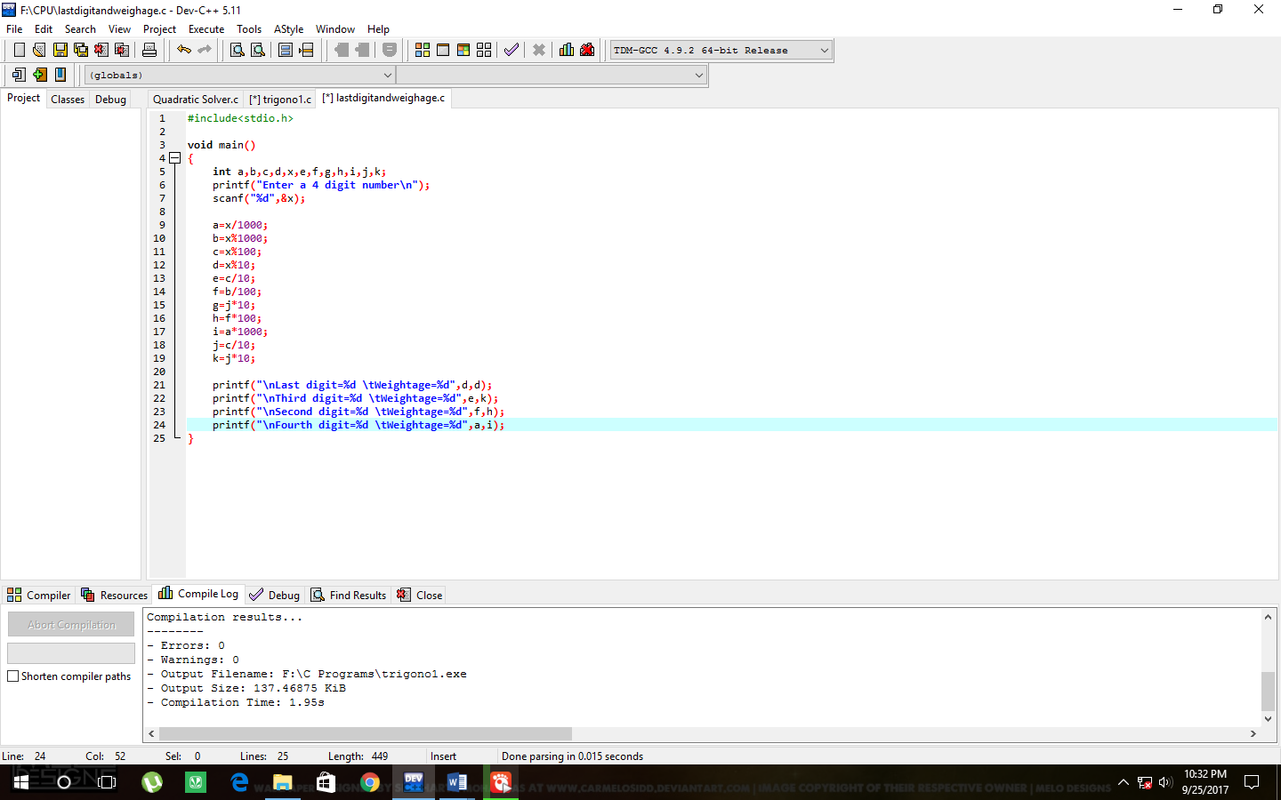

**Input and Output:**

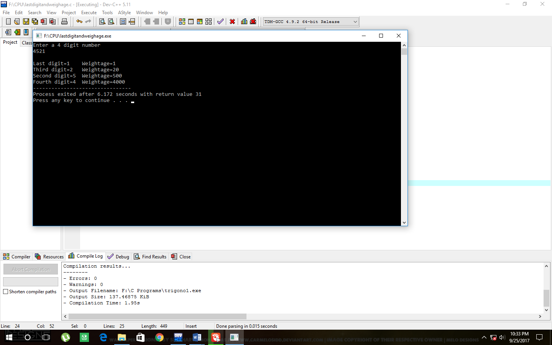

**Aim:** Write a program to find largest number and smallest number out of 2 numbers given as input. Use Conditional operator for this program.

**Program:**

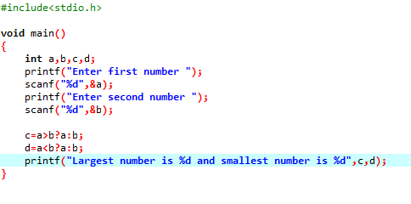

**Input and Output:**

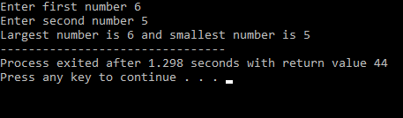

**EXPERIMENT 3:**

**Aim:** Write a program that accepts a character from keyboard and checks as follows:

- Whether the input character is a digit

- Whether the input character is a lower case letter

- Whether the input character is an upper case letter

- Whether the input character is a punctuation mark

- Whether the input character is a white space character

**Program:**

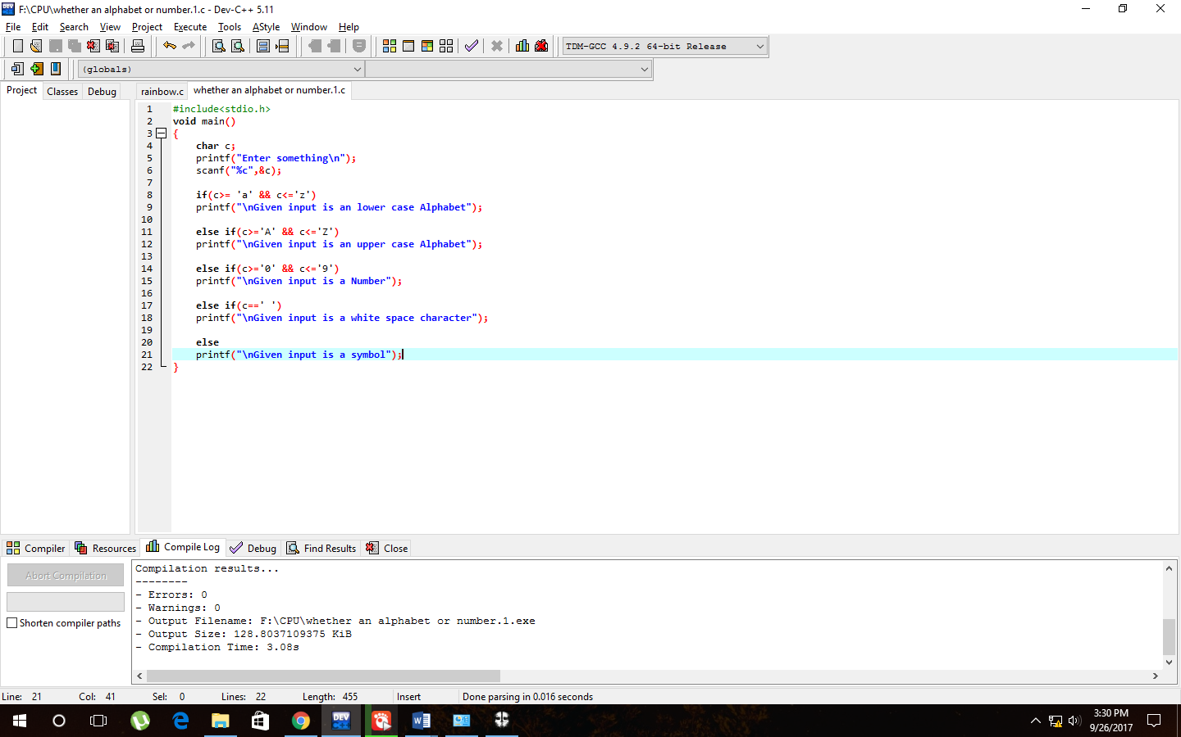

**Input and Output:**